eCMS MANUAL

Front End Registration

Department of Revenue and Customs
Ministry of Finance
Contents
1. TPN Search/ Track Application 1
2. CFA Authorization 3
3. CFA De-authorization 6
4. Registration 9
4.1. OTP based Authentication for Registration 9
4.2. Registration for FE Users: 11
4.3. Trader Registration: 12
4.3.1. CFA Registration: 15
4.3.2. Bonded Warehouse Operator (BWH) Registration 19
4.3.3. Temporary Storage Operator (TSO) 23
4.4. Logging in to eCMS 27
4.5. Logout of the FE Users: 28
4.6. Password Reset 29

TPN Search/ Track Application

The user who wishes to register into eCMS for trade related activity, should first update there TPN details in RAMIS system from DRC office.
Once the Trader/individual has updated their details, they can check in there TPN under the TPN Search/Track Application to check if the TPN is available in eCMS.
Go to your browser: type in www.ecms.gov.bt . In the home page under the heading eCMS e-Services. Click on the TPN Search/ Track Application:
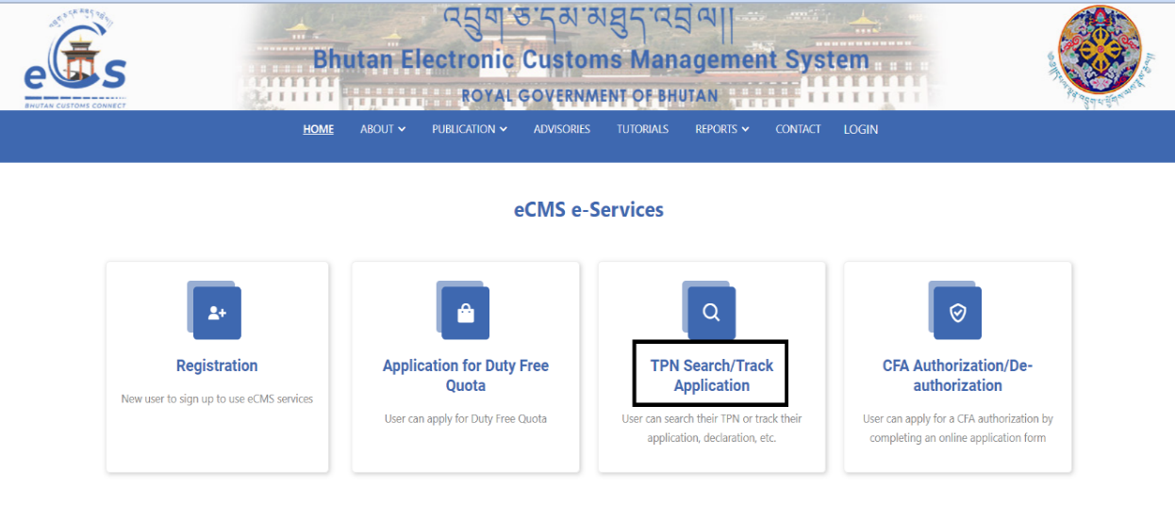
The below screen gets populated, here in you need to key in the primary TPN:

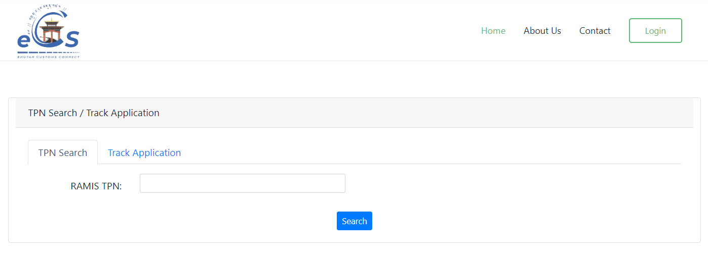

- Type in the primary TPN:

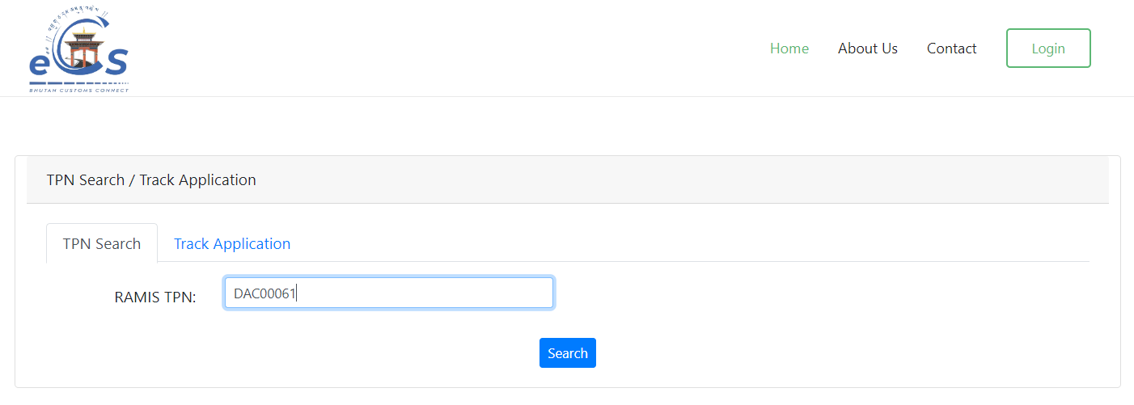

- The list of TPN associated to the trader will get populated, as the TPN has been updated in RAMIS:

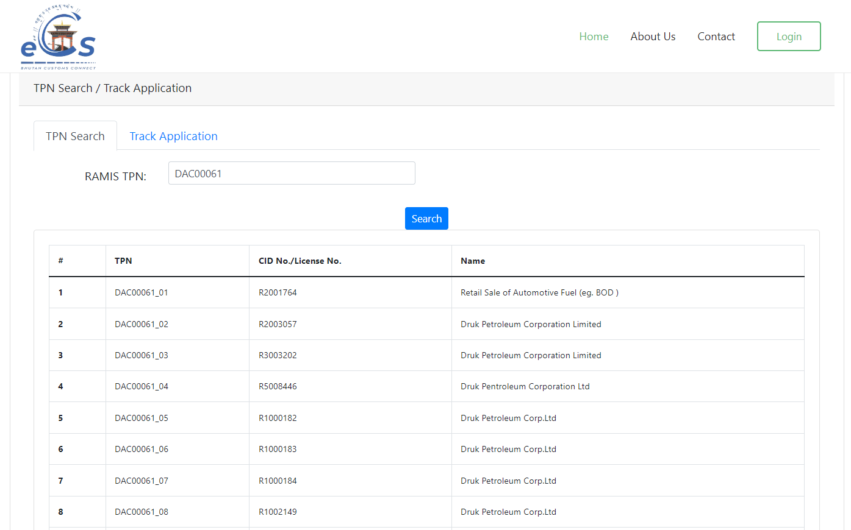

- Select the TPN which you wish to do trade and authorize the CFA with.
For example: Here the user wishes to do trade with TPN DAC00061_01 for trade, so we take that TPN to do the registration or do CFA authorization.

CFA Authorization

- Type in url: www.ecms.gov.bt

- Under the eCMS e-Services, Click on CFA Authorization/De-authorization.

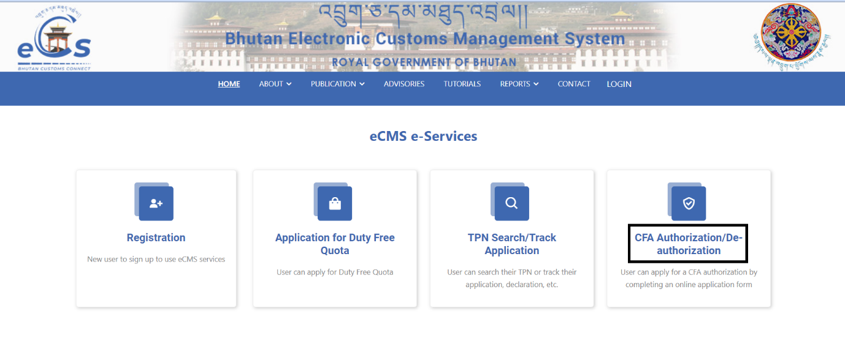

- OTP Authentication

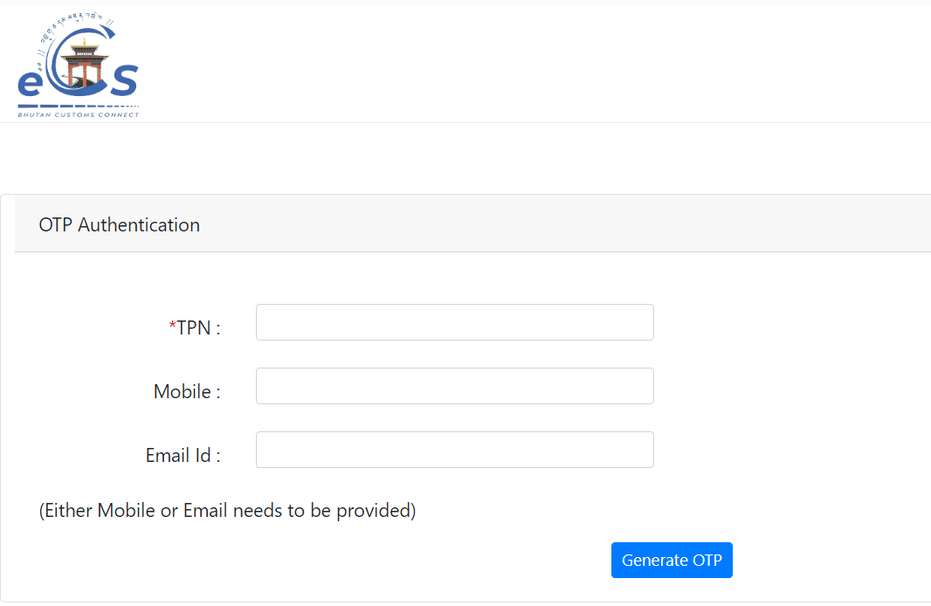

Here in we add the we want to use for trade and authorize the CFA for trade related activity:

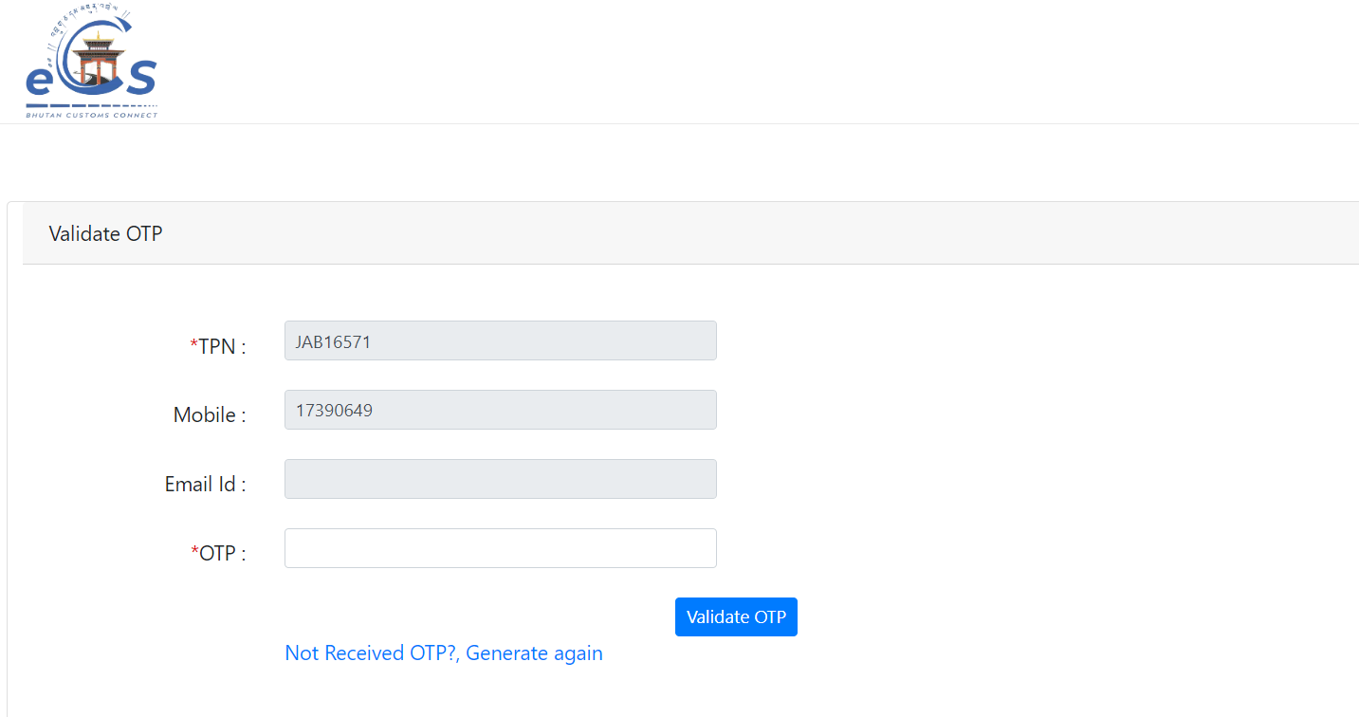

Details:
- TPN: The TPN of the Registered Trader
- Mobile: mobile number to get the OTP
- Email id: email id to get the OTP
Note: The user has to key in either mobile no or the email id for the OTP authentication.
- Key in the OTP received, and the validation happens, and the Registration tab appears.
- Click on the Registration Tab
- Select the option Apply CFA Authorization
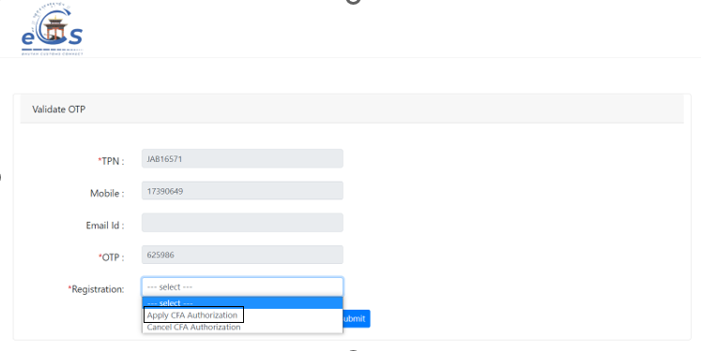
- Fill in the details in the field:

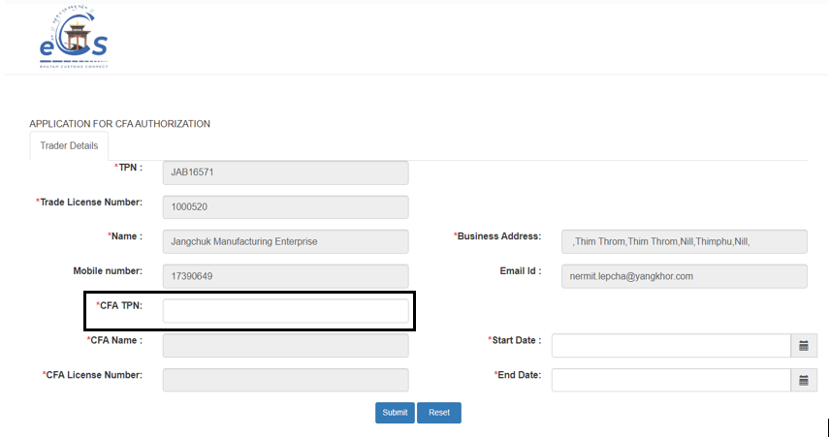
Details:
- CFA TPN: add in the CFA TPN to authorize the CFA for trade related activity.
- CFA name and CFA License Number gets auto- populated.
- Start Date and End Date: the date for the authorization period needs to be mentioned.

- Click on Submit button to Submit the application
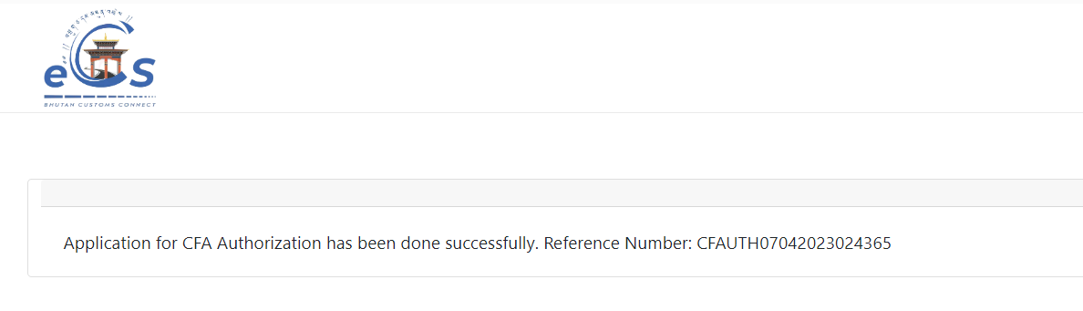
- The Application number gets generated for tracking.
- Once the application has been approved by the customs, the trader and CFA will be notified through the registered mail:
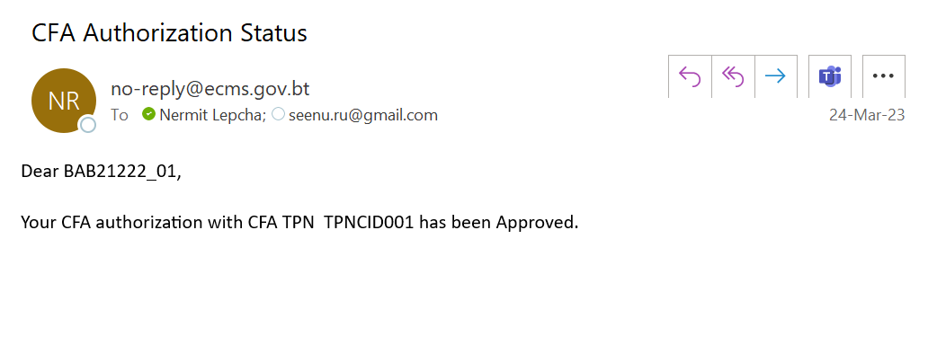

CFA De-authorization

- Type in url: www.ecms.gov.bt
- Under the eCMS e-Services, Click on CFA Authorization/De-authorization:



- OTP Authentication




Details:
- TPN: The TPN of the Registered Trader
- Mobile: mobile number to get the OTP
- Email id: email id to get the OTP
Note: The user has to key in either mobile no or the email id for the OTP authentication.

- Key in the OTP received, the validation happens, and the Registration tab appears.
- Click on the Registration Tab
- Select the option Cancel CFA Authorization

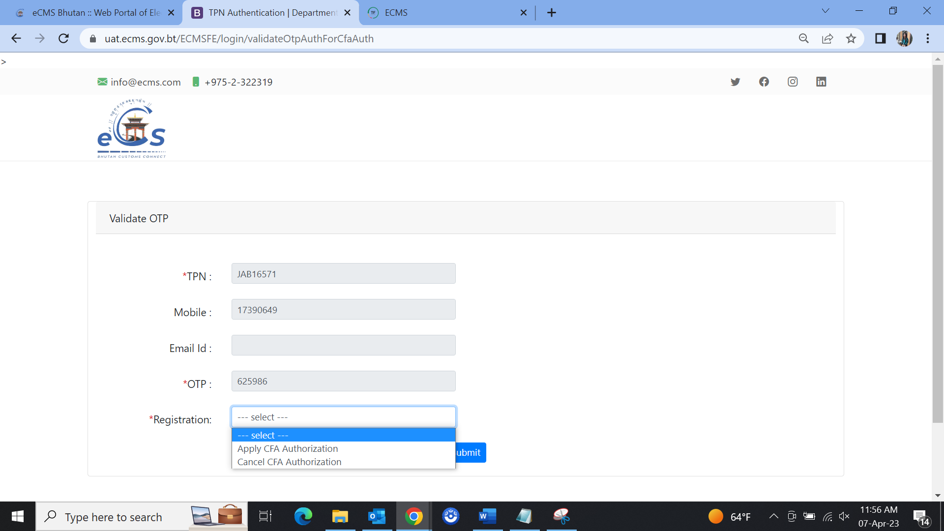\

- Select the dropdown My Authorized CFA TPN
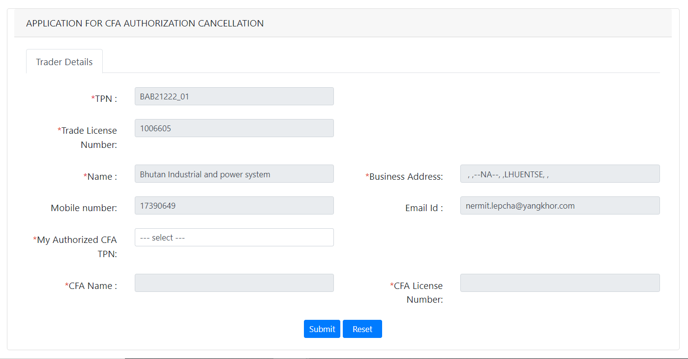
- It will list the CFA TPN authorized.
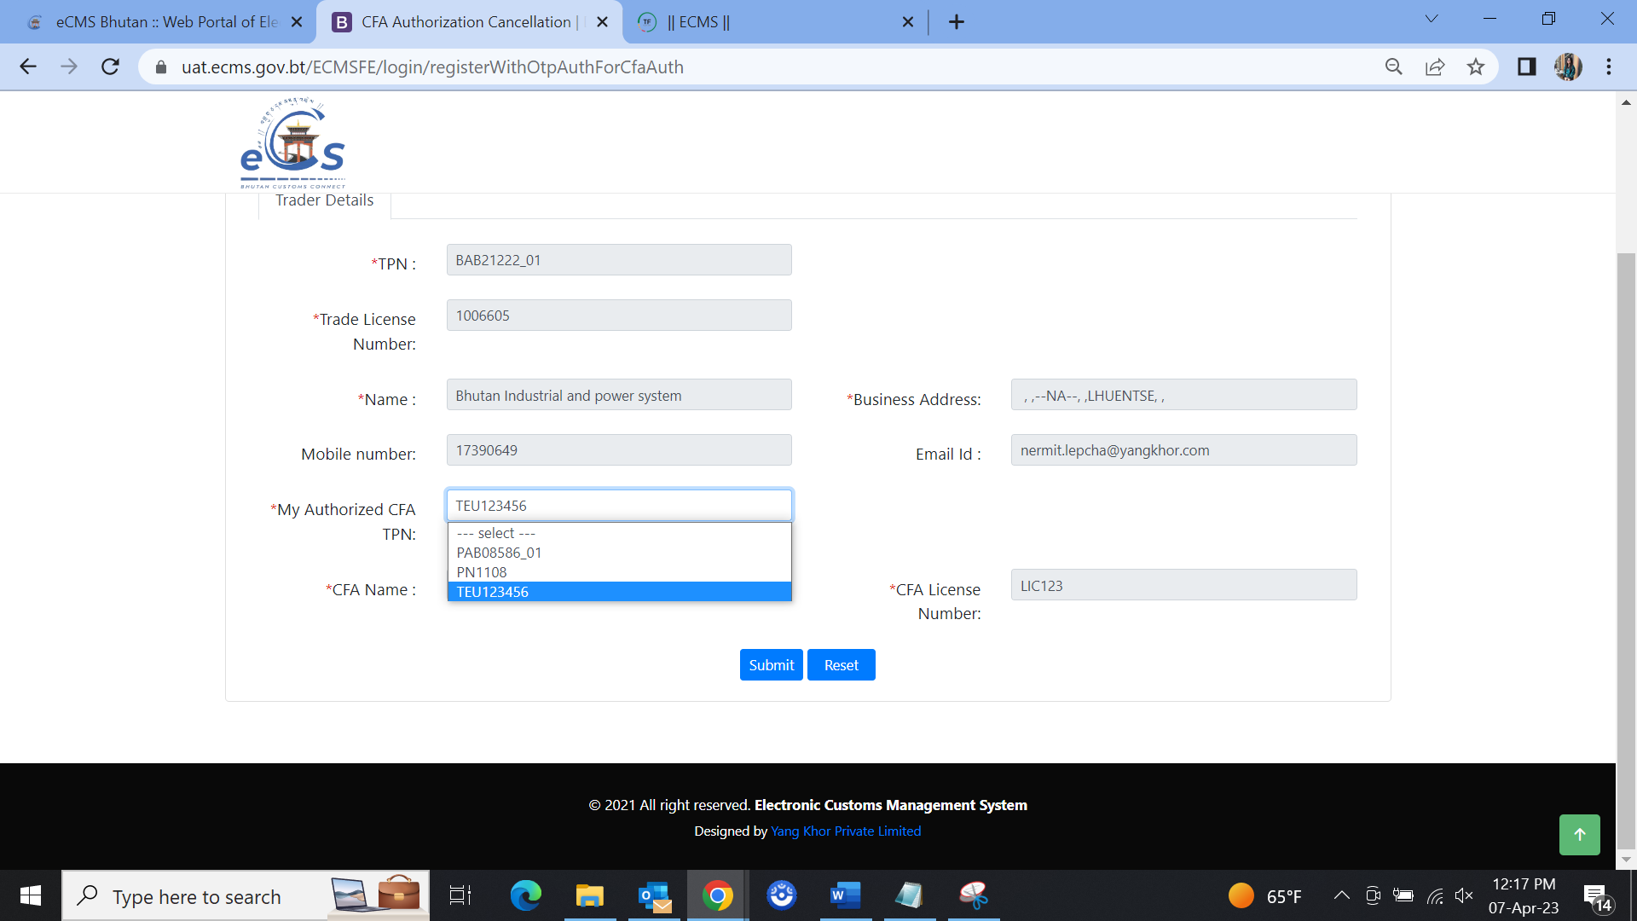
- Select the one you want the deauthorize.
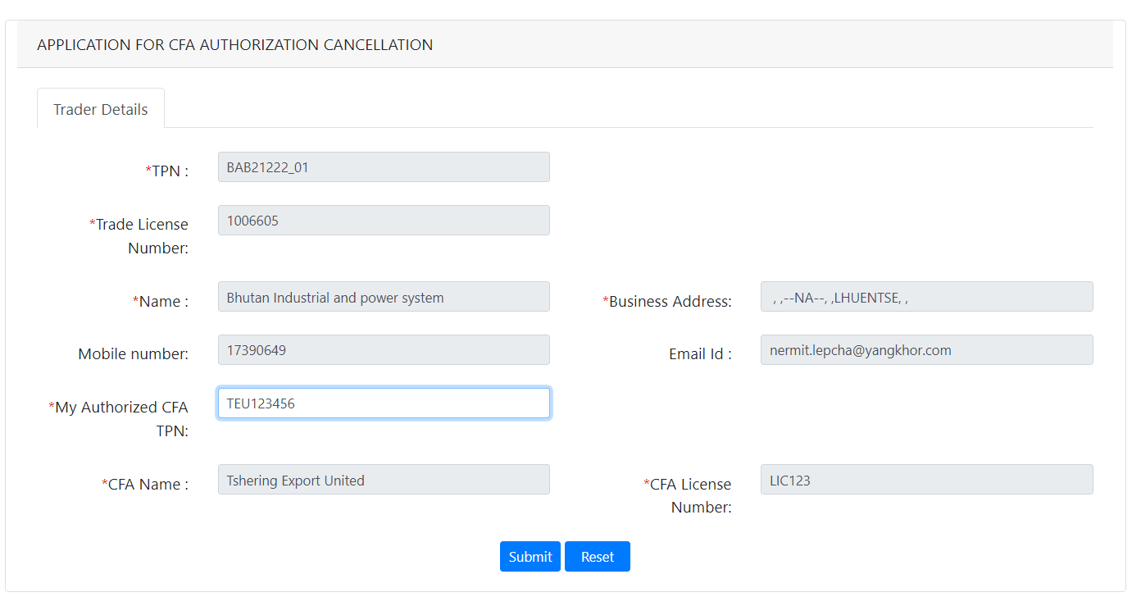
- Click Submit.
- The deauthorization remark for cancellation

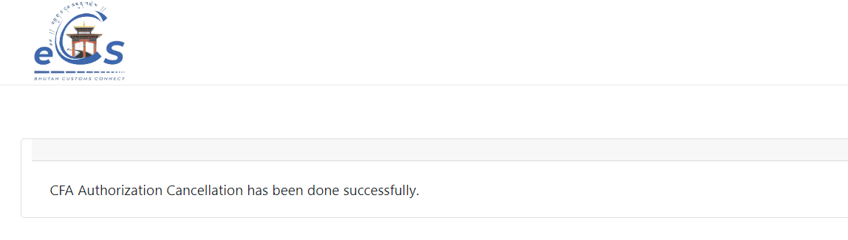
- The deauthorization or cancellation mail notification will be sent to the concern trader and CFA registered mail:

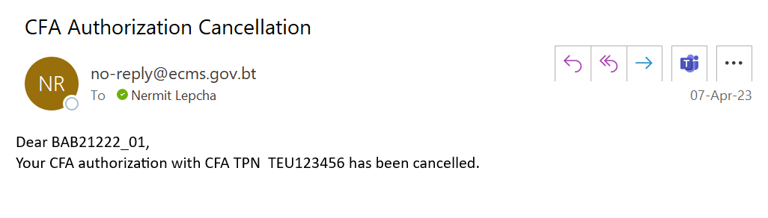

Registration

OTP based Authentication for Registration
The OTP based verification will ensure that the user who is applying for registration of a TPN in eCMS is a valid and authorized user. eCMS will send an OTP to the registered mobile or email of the TPN as available in eCMS TPN Master through RAMIS/BITS integration. Once the OTP is validated in eCMS, system will consider the user as valid and allow the user to register in eCMS (Please refer to Registration SRS for the various types of Registration).
For registration purpose, we will need to first go into the OTP based authentication where in you will be allowed to key in your TPN, registered email address and phone number to receive the OTP for authentication as in the process below:
To get into the authentication the users are to key in the url: www.ecms.gov.bt and then Click on Registration as highlighted below:
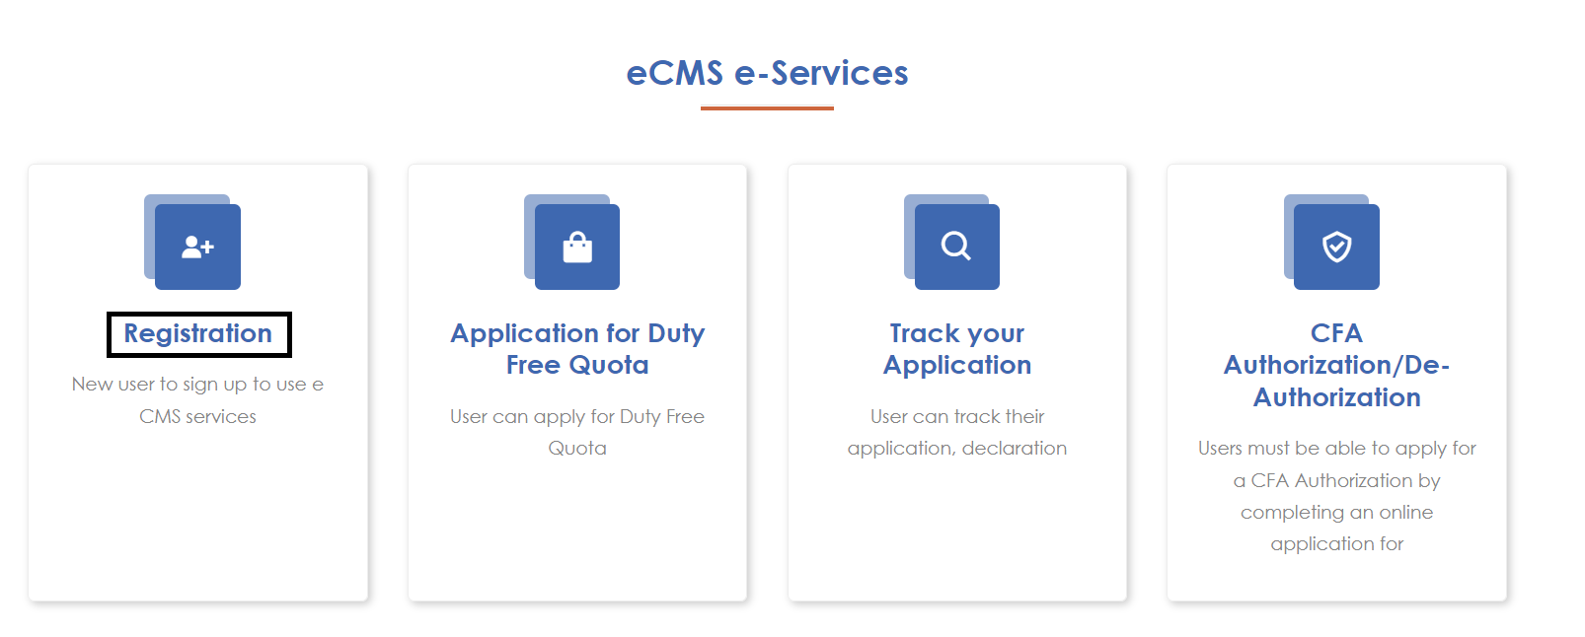
Figure 1.home screen
Step 1: User clicks on the Registration link in the eCMS Portal. System will navigate to OTP Authentication page.

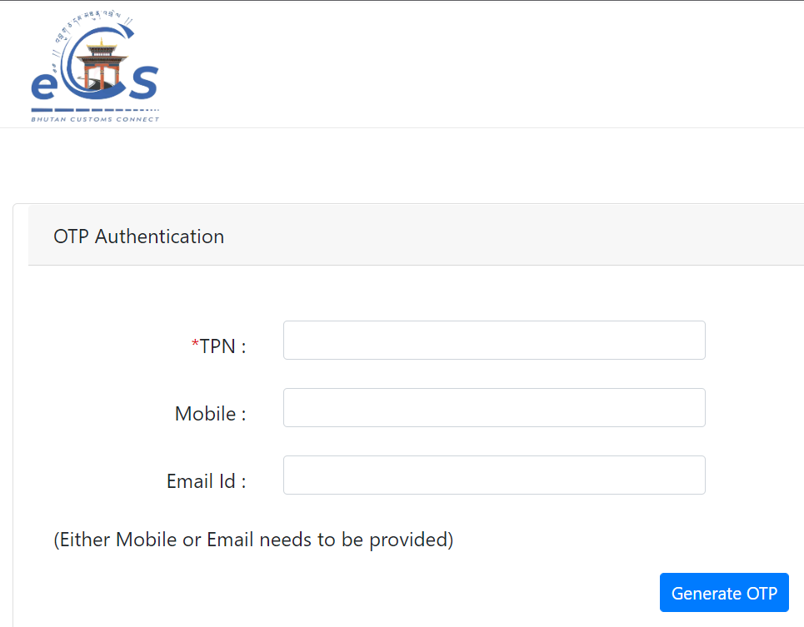
Figure 2.OTP Authentication Screen 1

Step 2: User provides necessary details and clicks on Generate OTP. System validates and sends OTP to the user. After successful sending of OTP, system enables the OTP entry for the user. User will need to key in the OTP received from eCMS to the registered email or the phone number and click on Validate OTP.

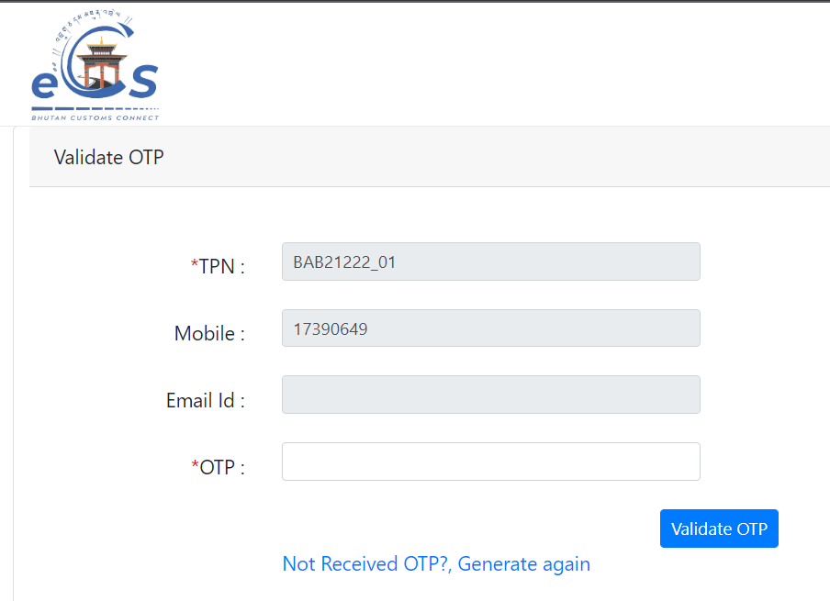
Figure 3.OPT Authentication Screen 2
Step 3: System will validate the OTP and, if it is found to be correct, it will allow the user to proceed with Registration.
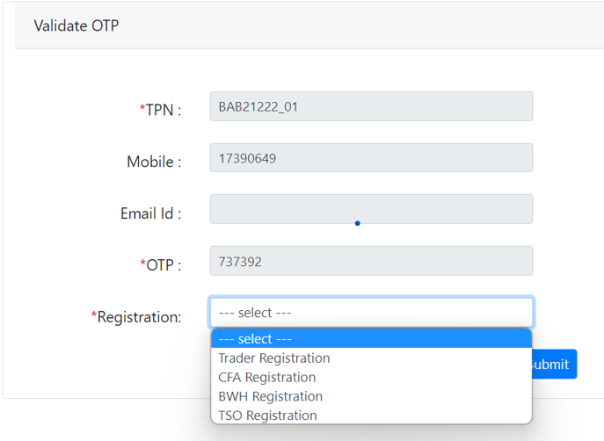
Figure 4.Registration List

Registration for FE Users:
To register into e-CMS:
After the OTP authentication is completed, the user can then select the user they want to register into as shown in the Figure 4. The individual user can register themselves as the following:
You can choose the option from the list for registration:
Field/Button description | Action/Input Required
Trader | Trader can register to get access to eCMS
Clearing & Forwarding Agents (CFA) | CFA can register to get access to eCMS
Bonded Warehouse Operator (BWH) | BWH can register to get access to eCMS
Temporary Storage Operator (TSO) | TSO can register to get access to eCMS

@ | For the user to register as Trader, CFA, BWH and TSO, they should have a valid TPN

Trader Registration:
Click >>Trader Registration:

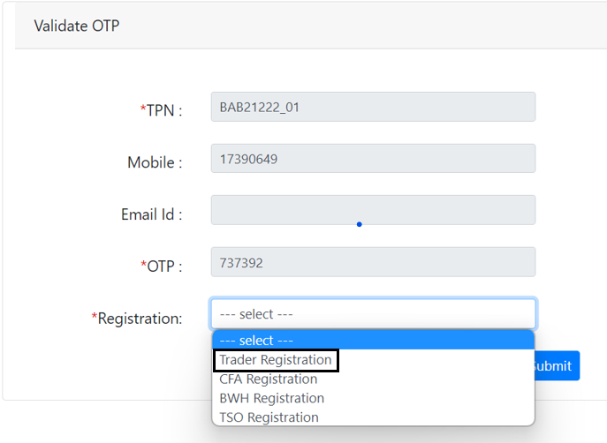

The subsequent screen will be displayed:

- Party Details:

- Input TPN Number: The system will validate if the TPN Number is PIT – The filed to add in the CID number will be appeared and if you select BIT & CIT – the filed to add in the Trade License number will be appeared.

TPN number if for PIT, the below screen shall be shown:
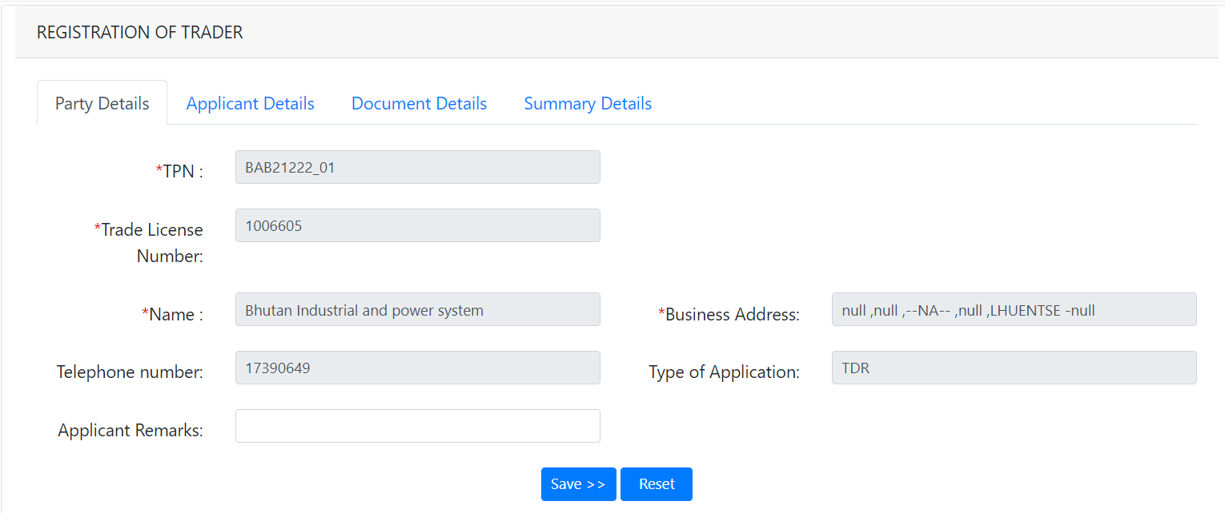
Figure 6.Trader Party details
Field/Button description | Action/Input Required
TPN | Taxpayer number that is received from the DRC
Trade License Number | Trader LIC no if the TPN is of type BIT & CIT
Name | Name of the user is fetched from the TPN Master which was registered with Custom Office
Business Address | Address of the register trader
Telephone number | Contact details of the applicant
Type of Application | The type of the applicant will be shown
Applicant Remarks | Remark if any should be provided here

- Application Details: general information of an individual.
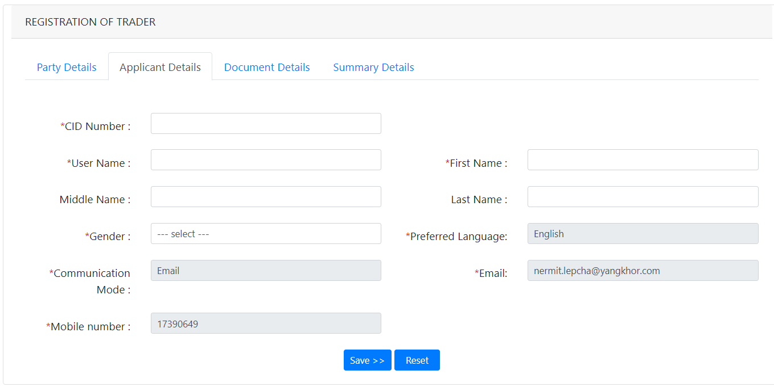

Field/Button description | Action/Input Required
CID Number | Provide your CID number
Login ID | Login id that you want to provide (this will be used later for logging in
First Name | Name of the Applicant
Middle Name | Middle name if any shall be provided
Last Name | Last name of the Applicant
Gender | Gender of the applicant
Preferred Language | What language you prefer can be shown here , as this has been filled at the TPN master creation time
Communication Mode | Mode the applicant wishes to get information on
Email | The applicant email, which will be used by the applicant and custom for communication
Mobile number | Mobile nos of the applicant

- Document Details

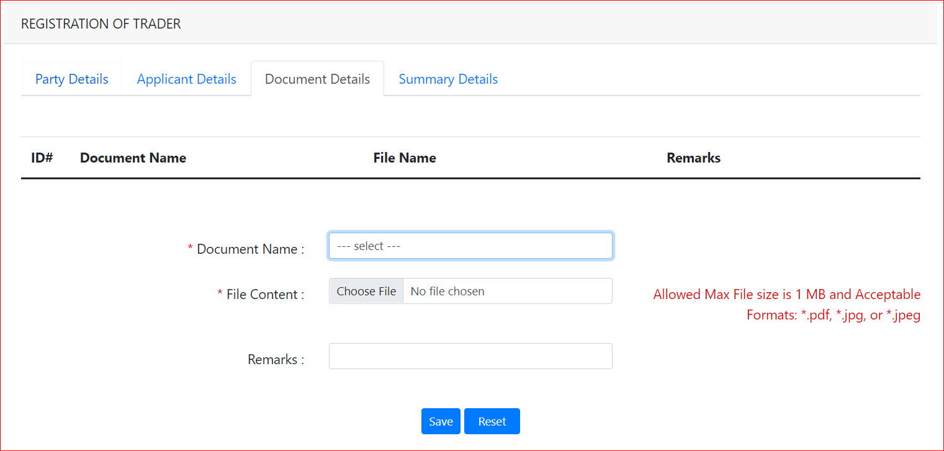

Field/Button description | Action/Input Required
Document Name | List of documents that needs to be uploaded will be listed , the applicant needs to select from the list and upload the same accordingly
File Content | Choose file to be attached
Remarks | Remarks if any should be provided

@ | For now, the trader has no documents to be uploaded.

- Summary Details and Submit
Summary details provides the view of certain details filled in by the user and the user need to tick the acknowledge and submit the same. Once submitted Registration number will be genetrated which shall be used to get the status:
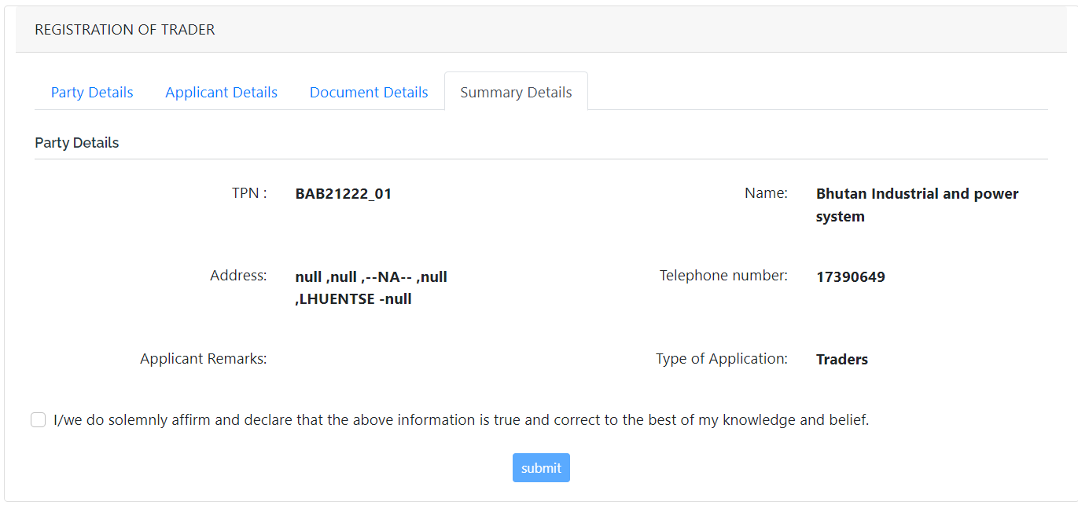

Click Submit >> The application is submitted, and Reg No is provided to you for tracking

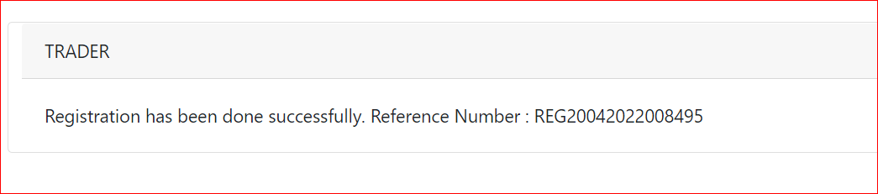

CFA Registration:
Click >>CFA Registration

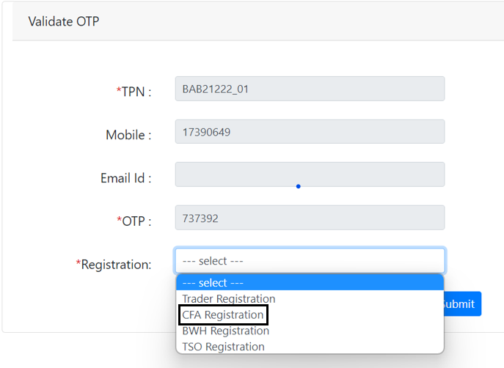

The subsequent screen will be displayed:

- Party Details:

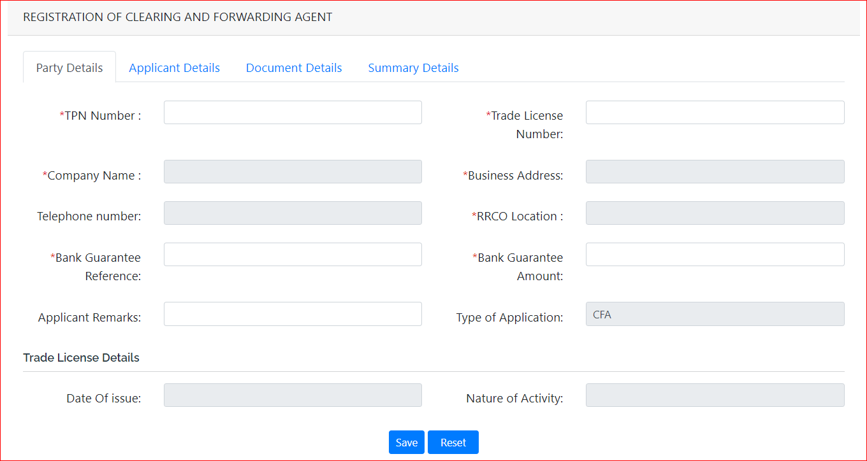

Field/Button description | Action/Input Required
TPN Number | Trader TPN Number
Trade License Number | Trader LIC no
Company Name | Name of the user is fetched from the TPN Master which was registered with Custom Office
Business Address | Address of the register trader
Telephone number | Contact details of the applicant
RRCO Location | Choose the RRCO the applicant belongs to
Bank Guarantee Reference | The type of the applicant will be shown
Bank Guarantee Amount | The amount that was paid in the form of Bank Guarantee
Applicant Remarks | Remark if any should be provided here
Type of Application | Give you the view of type: trade, CFA, WHO and TSO
Trade License details | Date of Issue: | Issue date provided in the License
 | Nature of Activity: | What’s the license for should be mentioned

- Application Details:
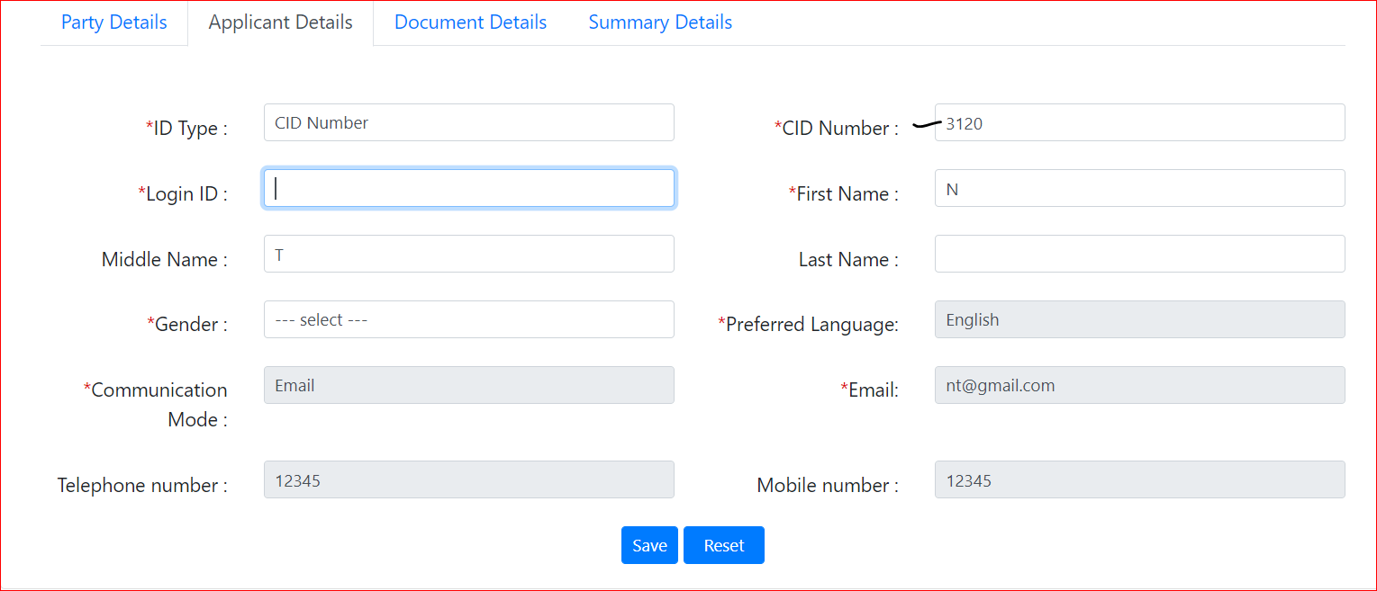

Field/Button description | Action/Input Required
ID Type | CID Number
CID Number | The CID number that belongs to the registered user
Login ID | Id that you wish to keep when you get your registration approved – username to login to the system
First Name | Your first name
Middle Name | Your middle name if you have
Last Name | Your last name
Gender | Your gender
Preferred Language | Language you would like to work in  note: currently we have English as the preferred language
Communication Mode | Phone or mail which way you wish the notification and import new to be given to you
Email | If you choose email- give your mail, if phone then your mobile number
Telephone number | Add in your company phone if any
Mobile number | Your mobile number

- Document Details

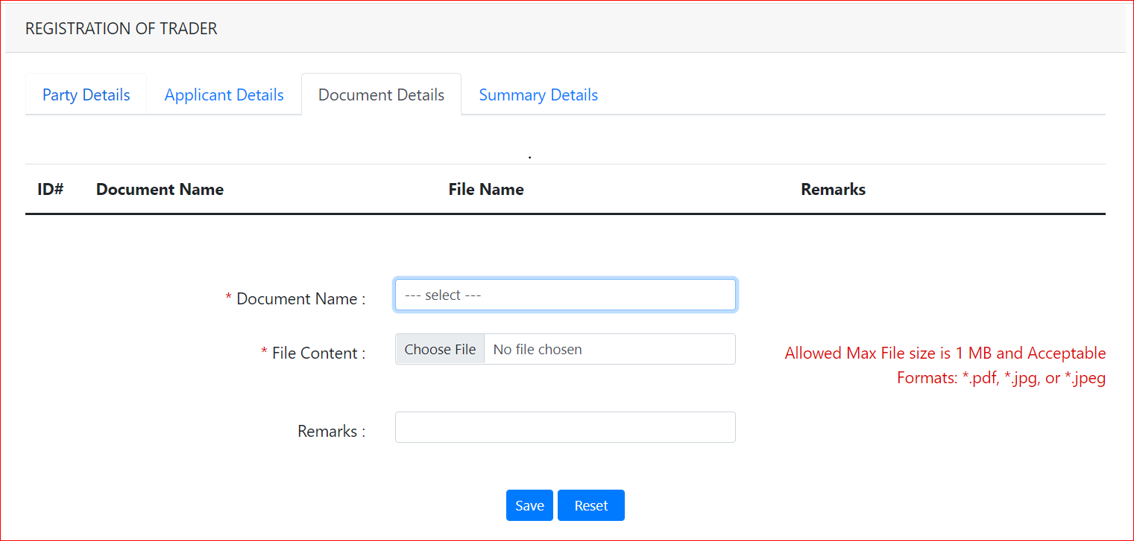

Field/Button description | Action/Input Required
Document code | List of documents that needs to be uploaded will be listed
File Content | Choose file to be attached
Remarks | Remarks if any should be provided

@ | For CFA – three different documents are to be uploaded when registration

- Summary Details and Submit

This will give the preview of the details one filled for registration, as shown below:
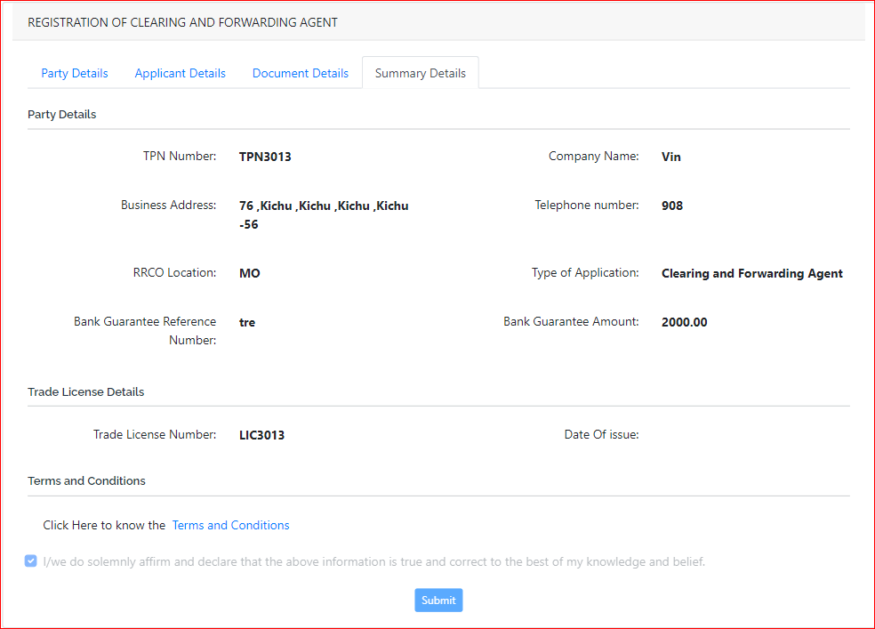
@ | For CFA – they need to agree to the Terms and Condition by clicking into it and then submit

Click Submit >> The application is submitted, and Reg No is provided to you for tracking

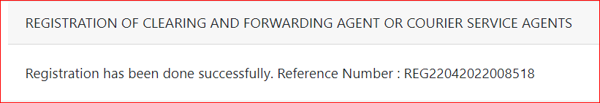

Bonded Warehouse Operator (BWH) Registration

Click >> BWH Registration

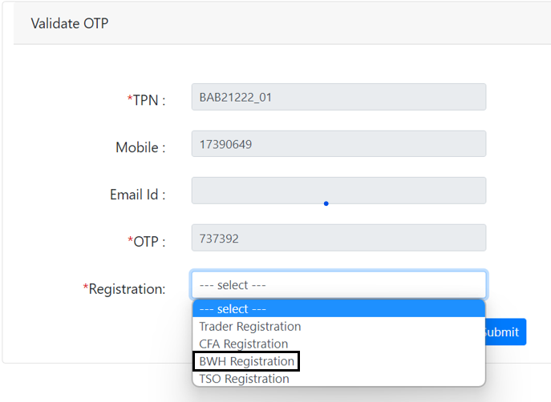

The subsequent screen will be displayed:

- Party Details:

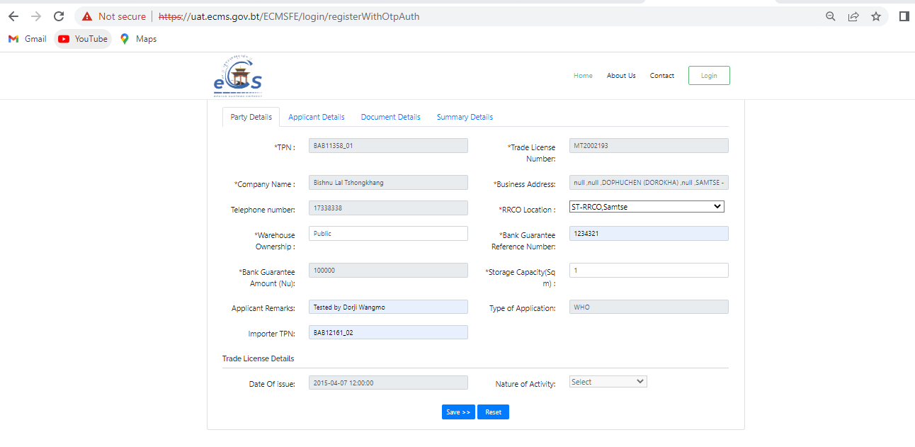

Field/Button description | Action/Input Required
TPN Number | Trader TPN Number
Trade License Number | Trader LIC no
Company Name | Name of the user is fetched from the TPN Master which was registered with Custom Office
Business Address | Address of the register trader
Telephone number | Contact details of the applicant
RRCO Location | Location of the register
Bank Guarantee Reference | Reference number of the bank guarantee
Bank Guarantee Amount | The amount that is there in the bank guarantee
Warehouse ownership | Here we need to select from two type: Public or Private
Storage Capacity | Capacity of the warehouse
Applicant Remarks | Remark if any should be provided here
Type of Application | The type of the applicant will be shown
Trade License details | Date of Issue: | License date
 | Nature of Activity: | Activity of the license holder and register

- Application Details:
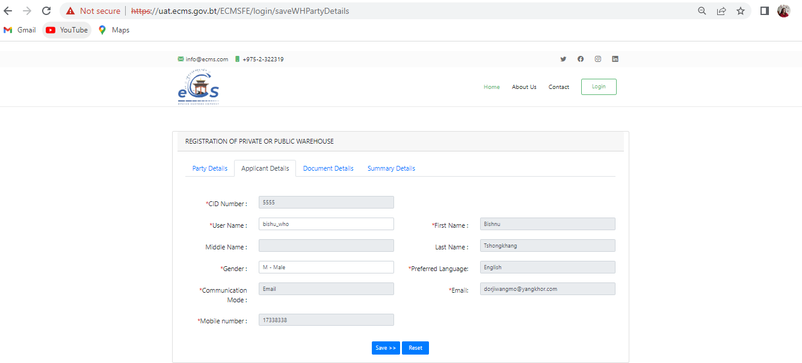

Field/Button description | Action/Input Required
CID Number | The CID number that belongs to the registered user
Username | Id that you wish to keep when you get your registration approved – username to login to the system
First Name | Your first name
Middle Name | Your middle name if you have
Last Name | Your last name
Gender | Your gender
Preferred Language | Language you would like to work in  note: currently we have English as the preferred language
Communication Mode | Phone or mail which way you wish the notification and import new to be given to you
Email | If you choose email- give your mail. If phone then your mobile number
Mobile number | Your mobile number

- Document Details


Field/Button description | Action/Input Required
Document code | List of documents that needs to be uploaded will be listed, here for BWH need to upload Bank Guarantee
File Content | Choose file to be attached from your system
Remarks | Remarks if any should be provided

@ | For BWH –need to upload BG  File to be uploaded should be of max size 1 MB and formats: pdf, jpg or jpeg

- Summary Details and Submit

This will give the preview of the details one filled for registration, as shown below:
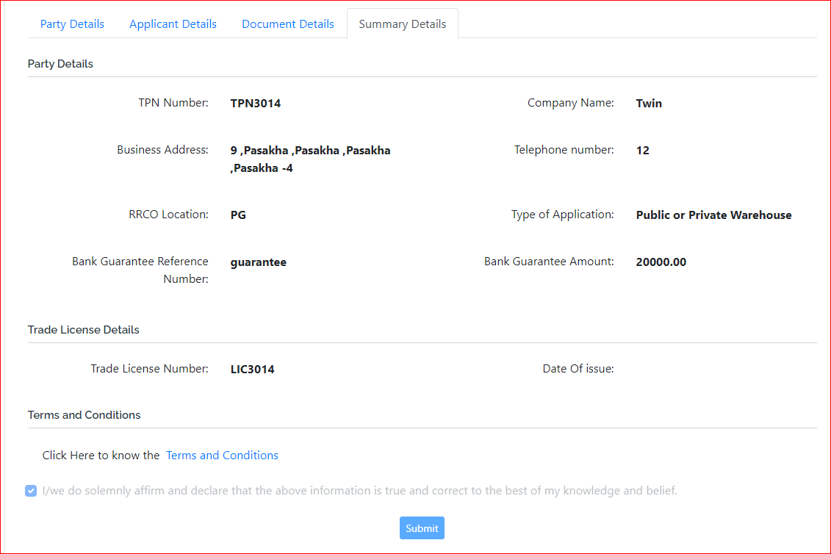
@ | For BWH – they need to agree to the Terms and Condition by clicking into it.

Click Submit >> The application is submitted, and Reg No is provided to you for tracking

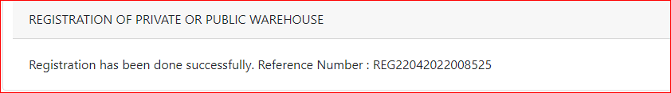

Temporary Storage Operator (TSO)

Click >> TSO Registration

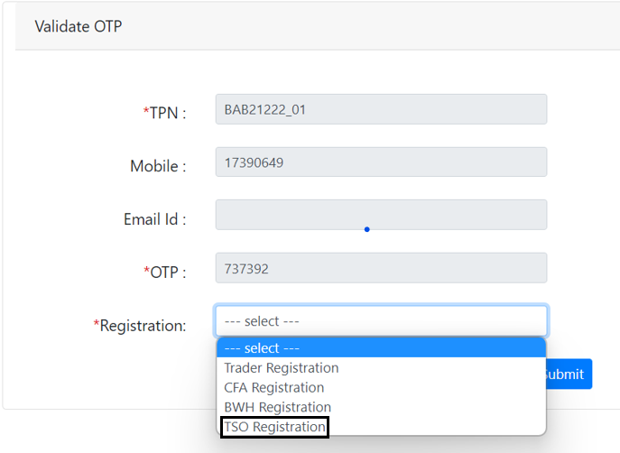

The subsequent screen will be displayed:

- Party Details:
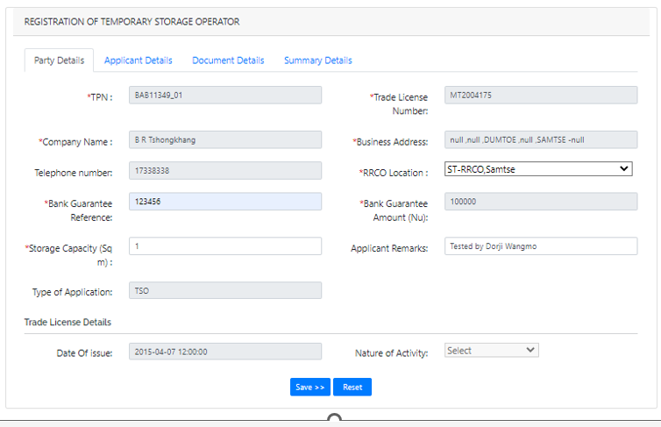

Field/Button description
TPN Number | Trader TPN Number
Trade License Number | Trader LIC no
Company Name | Name of the user is fetched from the TPN Master which was registered with Custom Office
Business Address | Address of the register trader
Telephone number | Contact details of the applicant
RRCO Location | Location of the register
Bank Guarantee Reference | Reference number of the bank guarantee
Bank Guarantee Amount | The amount that is there in the bank guarantee
Storage Capacity | Capacity of the warehouse
Applicant Remarks | Remark if any should be provided here
Type of Application | The type of the applicant will be shown
Trade License details | Date of Issue: | License date
 | Nature of Activity: | Activity of the license holder and register

- Application Details:
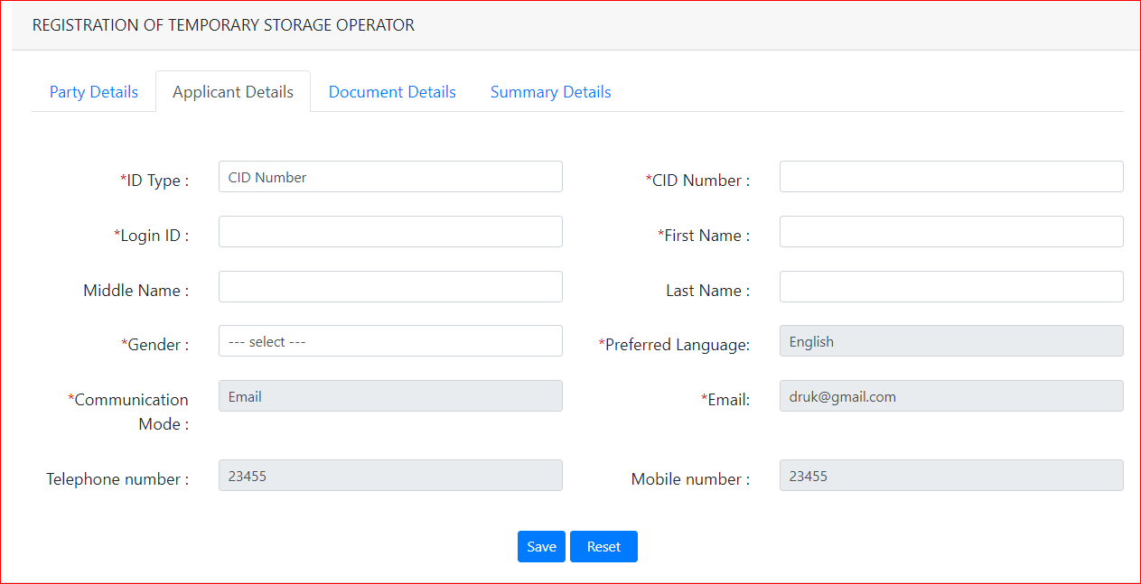

Field/Button description | Action/Input Required
ID Type | CID Number
CID Number | The CID number that belongs to the registered user
Login ID | Id that you wish to keep when you get your registration approved – username to login to the system
First Name | Your first name
Middle Name | Your middle name if you have
Last Name | Your last name
Gender | Your gender
Preferred Language | Language you would like to work in note: currently we have English as the preferred language
Communication Mode | Phone or mail which way you wish the notification and import new to be given to you
Email | If you choose email- give your mail. If phone, then your mobile number
Telephone number | Add in your company phone if any
Mobile number | Your mobile number

- Document Details



Field/Button description | Action/Input Required
Document code | List of documents that needs to be uploaded will be listed, here for BWH need to upload Bank Guarantee
File Content | Choose file to be attached from your system
Remarks | Remarks if any should be provided

@ | For BWH –need to upload BG  File to be uploaded should be of max size 1 MB and formats: pdf, jpg or jpeg

- Summary Details and Submit

This will give the preview of the details one filled for registration, as shown below:
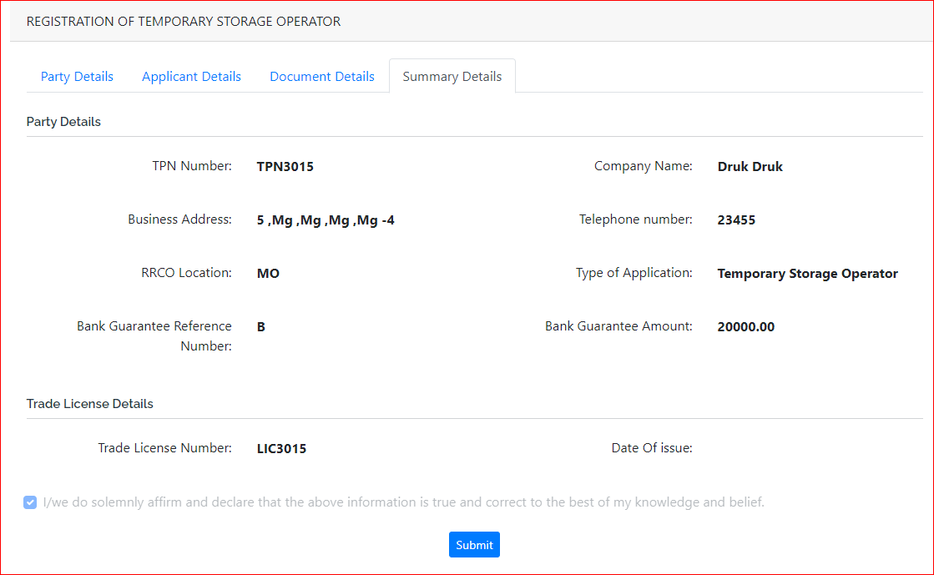

Click Submit >> The application is submitted, and Reg No is provided to you for tracking

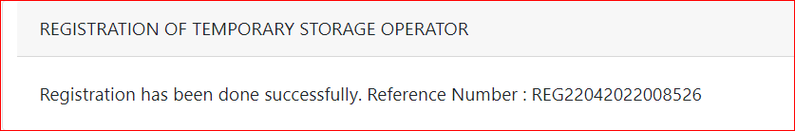

Note: Approval process is done by Custom Officer, once approval is done the user will receive the mail with username and default password

Password send to the provided registered mail id as shown below:

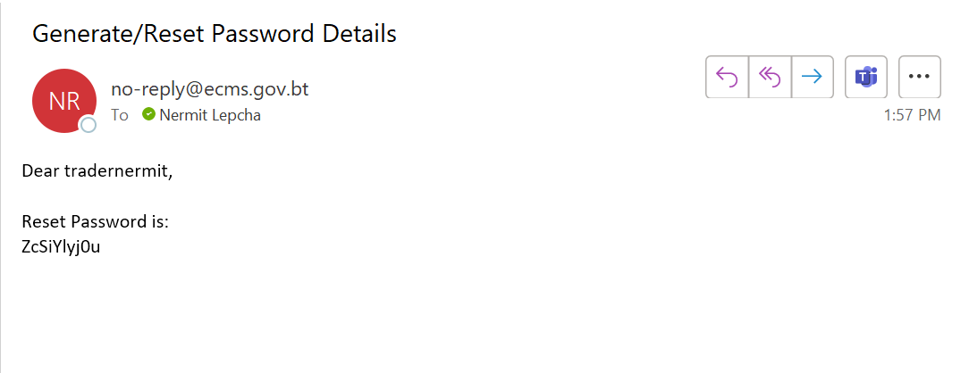

Logging in to eCMS
After the registration is completed, the individual will be provided with the login credentials username and default password, which will be asked to set while login for the first. Once completed the user can login to the portal and perform the task associated.

To login to the e-CMS FE:

- Type in URL: www.ecms.gov.bt in your Internet browser to access the e-CMS.
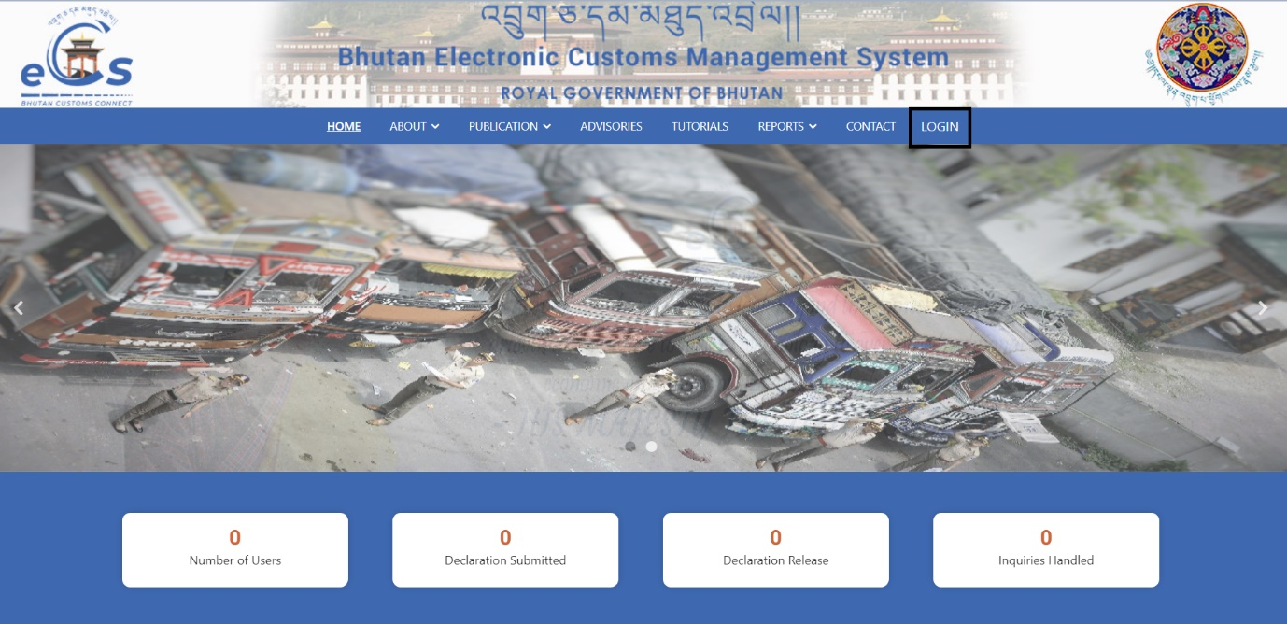

- Click on the Login you will be taken to the page to key in your username and password:
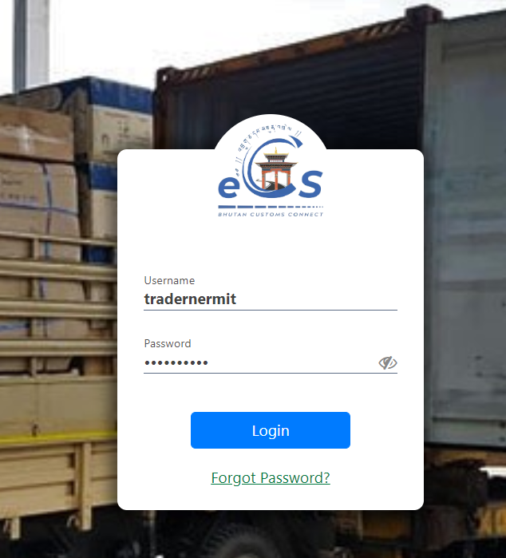

- Input the username and password that was created for the individual. (Trader, CFA, BWH, TSO), upon login with default the user will be asked to provide their own password for further use.
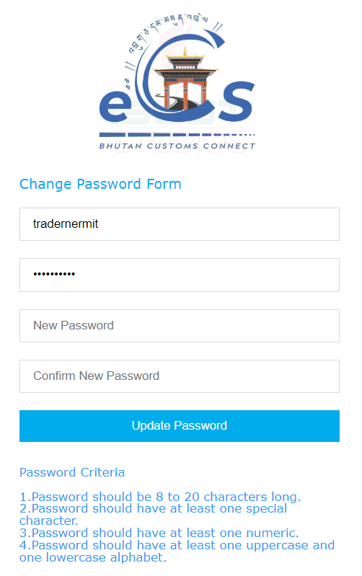
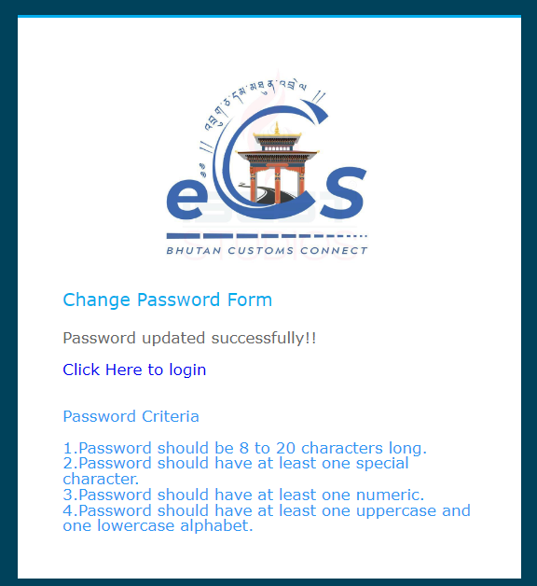

- After the process is done the user will be allowed to login with the password set by them self. For that click on Click Here to login
- After login in the user will be seeing their individual dashboard with various menu to perform different task.

Logout of the FE Users:
This function allows the user to log out from the application any time. User can sign out from the eCMS any time by simply clicking the button available at the upper right corner of the user logged-in window.

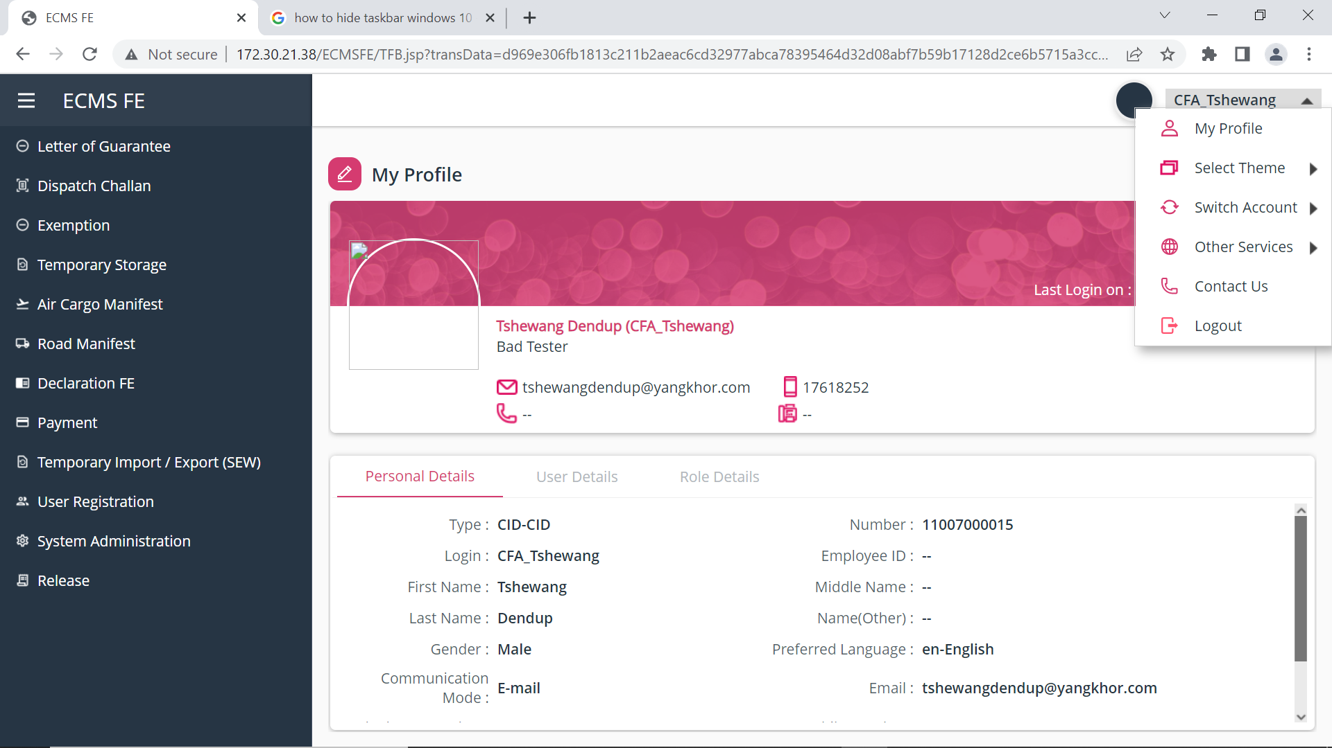
Log Out Page

Password Reset
The function allows to reset the password if the user forgets the password. Click on the Forget Password under the login tab as shown under:
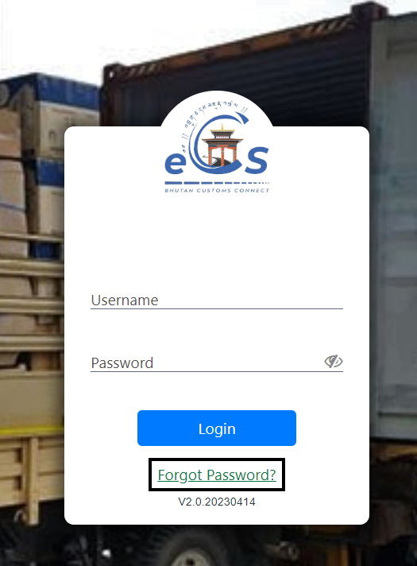
The next page to key in the username and registered main along with the captcha to authenticate will be provided.

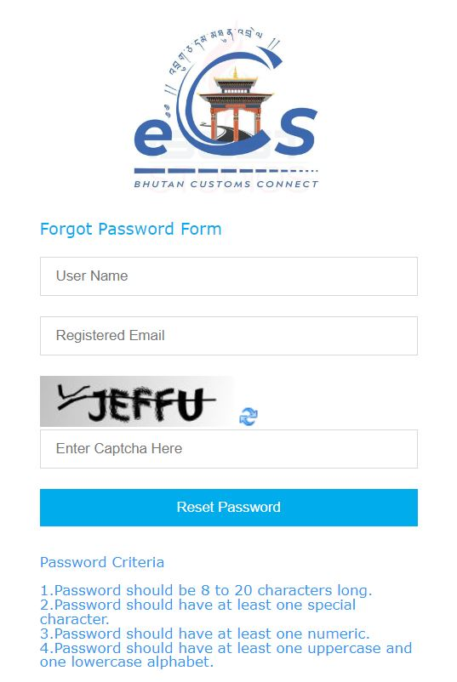
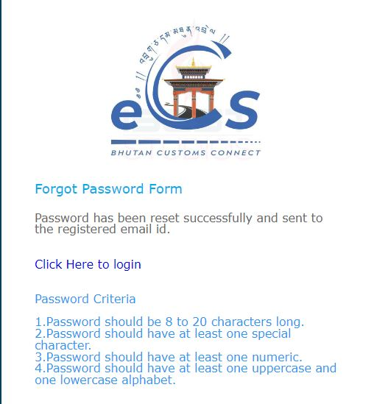
Once the user provided the credentials, the default password will be sent to the registered mail provide.
